Benchmarking the RAG Pipeline: An Empirical Evaluation of Chunking Strategies and Reranking across LLM Architectures

Abstract- Although RAG is the standard for anchoring LLM outputs in external evidence, it is highly dependent on the pipeline parameters. Here, we investigate the effect of chunking, retrieval depth (top-k), cross-encoder reranking, prompt strategy, context noise, and window sizes on answer quality. We tested 36 core and 324 extended components using all-mpnet base-v2 and FAISS with Gemma 3:12b and LLaMA 3.2:3b models on SQuAD v1.1. We observe that (1) 256 token chunks provide a 4.7-6.9% increase in F1 over 128-token segments; (2) retrieval depth is optimal at 3-5; (3) cross-encoders do not improve F1 at low k; (4) default prompts maximize token-level F1 at 0.72; (5) strict prompting combined with moderate noise (0.3-0.6) unexpectedly raises F1 to 0.75; and (6) RAG provides an estimated 7.6-fold increase over no-RAG values.

Index Terms - Retrieval-Augmented Generation, Chunking Strategy, Cross-Encoder Reranking, Prompt Engineering, Hallucination, SQuAD, FAISS, Open-Source LLM, Gemma, LLaMA, Noise Robustness

INTRODUCTION
The state-of-the-art LLMs are robust in an abundance of NLP tasks. But, they are limited by their fixed parameter knowledge and can produce plausible but unsupported information, such as hallucinations [6]. Retrieval-Augmented Generation (RAG) is an alternative to LLMs due to dynamic generation of documents from external sources, which ensures the model generates current and correct data rather than being conditioned upon learned associations [1].
Despite the broad adoption of RAG for enterprise search, law intelligence, and domain-specific question answering, its performance remains very susceptible to design decisions that are often unjustifiably made. Practitioners commonly choose chunk sizes, retrieval depth (top-k), reranking architectures, and prompt templates based on heuristics rather than systematic evidence [5][7]. Bad choices may lead to poor answer quality, hallucinations, or unnecessary computational overhead.
A third gap in the literature is the lack of study on how noise in the retrieval pool and context truncation affect generation quality. The real-world corpora are rarely crystal clear, and irrelevant passages can be retrieved alongside relevant ones. Previous research has shown that LLMs struggle to make sense of long contexts, particularly when relevant information is not located in the context well [8]. The relationship between retrieval noise, context length, and prompt strategy has been scarcely explored.
The purpose of this paper is to fill these voids with a controlled, multi-dimensional experiment. We test 36 core configurations with two chunk sizes (128, 256 tokens), three retrieval depths (k = 3, 5, 10), two reranking conditions, and three prompt templates, together with 324 extended configurations that further vary the noise injection ratio (0.0, 0.3, 0.6) and the maximum window size (2, 3, 5 chunks). We use 120 samples from the SQuAD v1.1 validation set with Gemma 3:12b as the generative model.This pilot cross-model comparison uses LLaMA 3.2:3b for a 30 sample subset of data.

The primary contributions of this work are:
- Controlled ablation in 36 configurations was used to isolate the independent effect of chunking, retrieval depth, reranking, and prompt strategy on token-level F1. All experiments were conducted under identical pipeline conditions.
- The extension study introduces noise injection and context window capping as new experimental dimensions, revealing non-intuitive interactions with the prompt strategy.
- Evidence showing that cross-encoder reranking at low k (3–5) does not do much good in a structured extractive process, and it produces a slight reduction at k = 10.
- The finding that noise injection (ratio 0.3–0.6) combined with strict prompting raises F1 above clean-body baselines is paradoxical; it suggests that verbositay is filtering.
- In a pilot study comparing the LLaMA 3.2:3b models, it was shown that, under similar pipeline conditions, the smaller 3B model is significantly lower F1 (at its best 0.35). So the primary model was Gemma 3:12b.
The paper organization is as follows: Section II addresses the related work done around RAG. Section III describes the methodology used in the paper. Section IV shows the implementation and result analysis of various pipelines and outcomes we got. Section V highlights the various challenges encountered while the cumulating the results. Section VI highlights the differences between models and various chunk sizes. Section VII concludes the overall paper by highlighting the limitations that this study was conducted on small dataset and only 2 models instead of the number of models.

RELATED WORK
The first version of the RAG architecture proposed by Lewis et al. [1] utilized a Dense Passage Retriever (DPR) and a BART seq2seq generator over a Wikipedia index. They show that conditioned generation upon retrieval may be an effective method of knowledge-intensive NLP. Izacard and Grave [2] extend this with Fusion-in-Decoder (FiD), showing that conditioning on multiple retrieved passages improves open-domain QA, especially when evidence is fusioned during decoding. Some of the work since then has been on robustness and control. Self-RAG [3] introduced adaptive and on-demand retrieval via self-reflection tokens, which allow models to decide at run-time whether to retrieve and whether to generate. CRAG [4] extended this by scoring documents retrieved and generating corrective actions when evidence is deemed noisy, something exactly what we did in our noise injection experiments. Evaluation has become an important field of study.

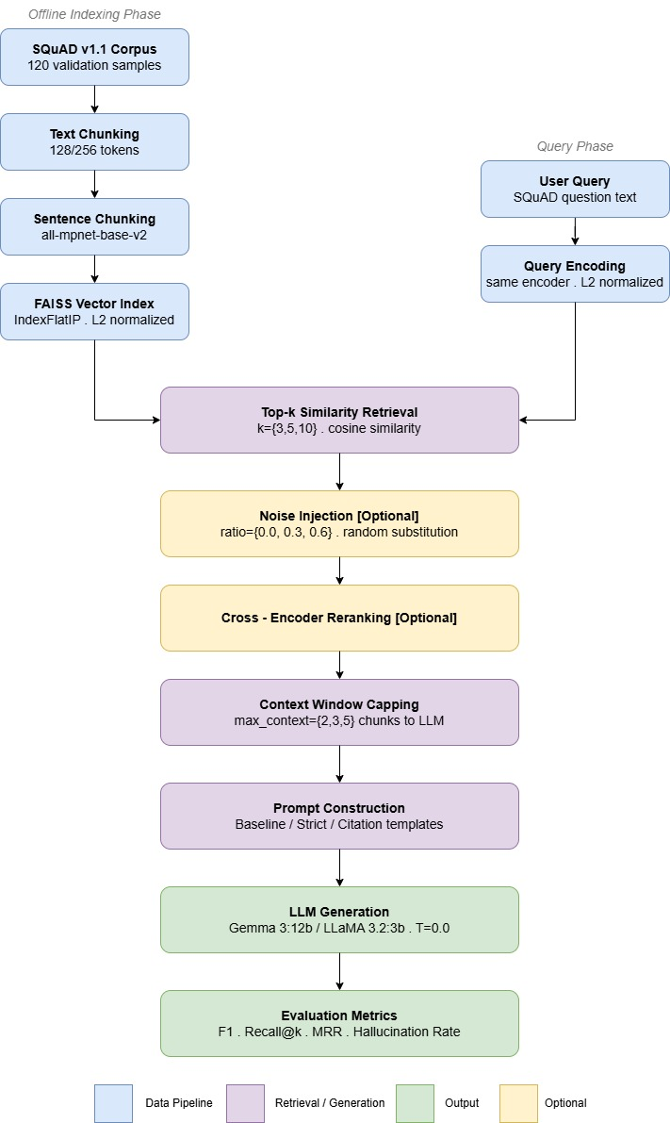
RAGAs [5] proposed a reference-free multidimensional evaluation model that includes faithfulness, relevance of answer, context precision, and recall of context that is in line with the metric design in our extended study. RAGTruth [6] added an annotation corpus for hallucinations in RAG outputs, driving us to prioritize hallucination rate as a first class metric alongside F1. RAGBench [7] mapped evaluation across enterprise-relevant domains and task types.

Liu et al. [8] found that LLMs underutilize context in the middle of a long passage, and that performance is affected by the position of the relevant passage. This leads us to investigate the size of the maximum context window. If models fail to exploit all chunks of a long context, perhaps it is desirable to limit the size of the context window to 2–3 chunks rather than passing all retrieved passages. A slightly more recent article [9] suggests that fixed chunk sizes deconstruct unit semantics, reducing retrieval recall, which prompted our study of 128 vs. 256-token chunks. To our knowledge, no other paper has examined the interaction between retrieval noise, context window capping, and prompt strictness in one controlled RAG model. Our paper fills this gap.

METHODOLOGY
A. Pipeline Architecture
The RAG test implementation follows the standard retrieve-rerank-generate protocol. The context is segmented into fixed-size chunks of text, encoded using the all-mpnet-base-v2-sentence encoding [768-dimensional], and stored in a FAISS IndexFlatIP index with L2-normalized inner product similarity. When a query is inserted, the top k most similar chunks are retrieved by cosine similarity. When cross-encoder reranking is enabled, the top k most similar chunks are re-scored using the cross-encoder/ms-marco-MiniLM-L-6-v2 model, and re-ordered. A configurable number of top chunks (max_context 2, 3, 5) are merged together into a prompt and sent to the generative model via Ollama API with a temperature = 0.0 for deterministic output.

B. Experimental Variables
Independent variables in the extended study are (1) Chunk size (128 and 256 tokens) with a fixed overlap of 32 tokens; (2) Top-k > 3, 5, 10; (3) Reranking: disabled (cosine similarity only) and cross-encoder reranking. (4) Prompt strategy: one of the three template shown below. (5) Noise level: 0%, 30%, and 60% of the chunks retrieved are replaced with random non-relevant corpus chunks. (6) Maximum context: 2, 3 or 5 top chunks passed to the generator after any reranking. The core study (no noise, max_context = 5) produces 36 configurations; the full factorial extended study gives 324 configurations.

C. Prompt Templates
Three prompt templates are considered: The Baseline prompt requires that the model respond only to the context provided. The Strict prompt asks the model to respond with "Not found" if their answer is not fully supported by the passage retrieved. Recall is replaced with hallucination control. The Citation prompt requires the model to bracket chunk identifiers (e.g., [1], [2]) in each statement, and grounding at the claim level is made explicit. These three prompt templates can range from liberal responses to conservative grounding.

D. Models and Infrastructure
Gemma 3:12b is the first generative model and is an instruction tuned model from Google with good performance for its number of parameters. We also ran LLaMA 3.2:3b (Meta AI) on 30 samples. The two models are served locally by Ollama with temperature = 0.0 and stream = False. The embedding model is SentenceTransformers all-mpnet-base-v2 and the reranker is cross-encoder/ms-marco-MiniLM-L-6-v2. The vector index is FAISS IndexFlatIP normalized to L2. All experiments were run on a single GPU. Response caching was used at the prompt-hash level to cut back on overhead from LLM calls.

E. Dataset and Evaluation
All experiments use 120 of the samples from the SQuAD v1.1 [10] validation split for a control frame with a well-constructed triple of question-answer-context. Because SQuAD is extractive, it is not possible to measure the retrieval-generation interaction since the correct answers are verbatim in the context and can be attributed correctly. As previously mentioned, we measure F1 in token format, normalized by lowercase and punctuation, as per SQuAD protocol. Other measures include Recall@k (whether the gold answer appears in any returned chunk), MRR, hallucination rate (whether the predicted answer is unsupported by the context), and average answer length. Standard deviation of F1 across queries is reported to judge output consistency.

RESULTS
A. No-RAG Baseline
The retrieval-free Gemma 3:12b subset of 120 sample SQuADs has a mean F1 of 0.0945, indicating that the model cannot answer SQuAD questions from parametric memory. The no-RAG F1 of LLaMA 3.2:3b pilot is roughly the same; 0.08–0.10 on the 30-sample subset. Both analyses show that retrieval is necessary in order to ground the model in domain-specific extractive QA.

B. Overall RAG Performance (Core Study)
Representative models from the core study without noise, max_context = 5. The highest-performing Gemma 3:12b model with chunk = 256, k = 5, reranking off, baseline prompt, has F1 = 0.7195±0.3821 (-7.6 difference from the no-RAG control). The large standard deviations across the configurations reflect a bimodal F1 distribution: when retrieving the correct chunk and the answer is short and extractive, the F1 is near 1.0, whereas if the chunk is not found, F1 is near 0.0.

Table I: Core Study Results – S elected Configurations (Gemma 3:12b, 120 Samples)

Config | Chunk | k | Rerank | Prompt | F1 Mean | F1 Std
No-RAG baseline | - | - | - | - | 0.0945 | -
Best overall | 256 | 5 | Off | Baseline | 0.7195 | ±0.3821
 | 256 | 3 | Off | Baseline | 0.7149 | ±0.3819
 | 256 | 3 | Cross | Baseline | 0.7149 | ±0.3819
 | 256 | 5 | Cross | Baseline | 0.7195 | ±0.3821
 | 128 | 3 | Off | Baseline | 0.6732 | ±0.4130
 | 256 | 3 | Off | Strict | 0.6582 | ±0.4199
 | 256 | 10 | Off | Baseline | 0.7195 | ±0.3821
 | 256 | 10 | Cross | Baseline | 0.7028 | ±0.3913
 | 256 | 3 | Off | Citation | 0.1904 | ±0.1275
*Note: All results: no noise injection, max_context = 5. Best F1 in bold. No-RAG uses parametric generation only

C. Effect of Chunk Size
As Table II shows, a chunk of 256 tokens will always outperform a chunk of 128 tokens. At k = 3, the baseline prompt is reranked off and Gemma 3:12b has F1 = 0.7149 (256 tokens) to 0.6732 with a chunk of 128, an increase of 0.0417 (6.2%); at k = 5, the gain increases to 0.0467 (6.9%). The same holds true for strict and citation prompts, although in relative terms. The biggest increase in absolutes is seen for the citation prompt (+0.0085) and appears to come from the citation prompt. It's most likely because the wording of the citation prompts, not to be as it dominates in F1, regardless of the chunk size.

The larger chunks have the advantage of being more semantically coherent (256-token chunks contain complete sentences and multi-sentence answer spans while chunks with 128 tokens may fragment the answer into separate chunks). When the gold answer spans a chunk boundary, it is less likely to be remembered by the smaller chunk since neither fragment contains the full answer.

Table II: Effect of Chunk Size on F1 Score (Gemma 3:12b, Baseline Prompt, Reranking Off)
Prompt Type | Top k | Reranking | F1 (128) | F1 (256) | Δ F1 | % Improvement
Baseline | 3 | Off | 0.6732 ±0.413 | 0.7149 ±0.382 | 0.0417 | 0.062
Baseline | 5 | Off | 0.6728 ±0.414 | 0.7195 ±0.382 | 0.0467 | 0.069
Strict | 3 | Off | 0.6193 ±0.442 | 0.6582 ±0.420 | 0.0389 | 0.063
Strict | 5 | Off | 0.6318 ±0.431 | 0.6721 ±0.407 | 0.0403 | 0.064
Citation | 3 | Off | 0.1819 ±0.132 | 0.1904 ±0.127 | 0.0085 | 0.047

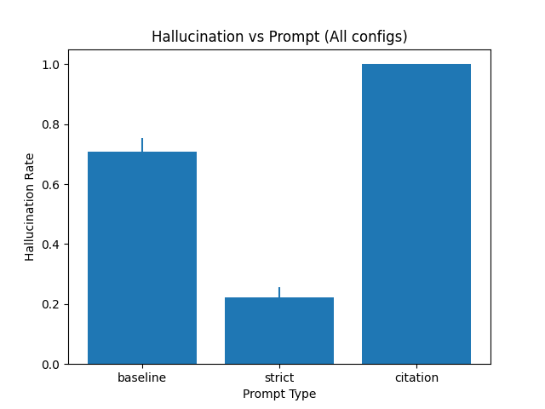
D. Effect of Retrieval Depth (top-k)
The F1 change for the base prompt by increasing k from 3 to 5 is negligible or minimal (0.7149- 0.7195, +0.7%), suggesting that the most relevant chunk of information is among the top 3 results. The recall@k metric also rises significantly with increased k (0.900 at k = 3 to 0.933 at k = 5, suggesting that more queries have the gold answer in the response set (but the generator does not always deliver it when the context is longer). At k = 10, the F1 value of reranking-off configurations is equal to k = 5, but the relative ordering of rerankers was lower (0.7195-0.7028), likely because the relative ordering of the reranker is less reliable over a larger, more diverse set of queries. This suggests that k = 3–5 is Pareto-optimal for balancing recall@k coverage against generation focus.
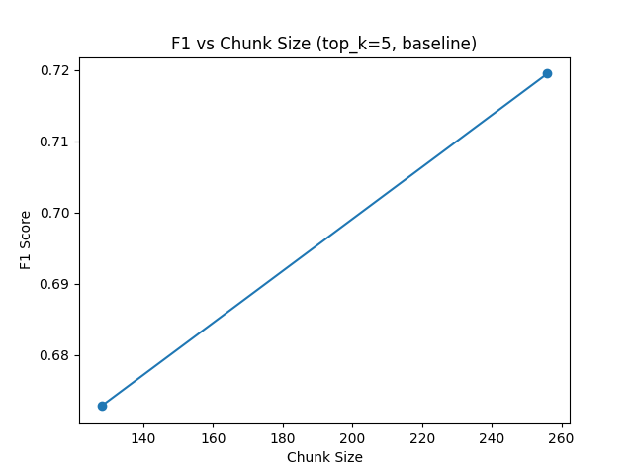

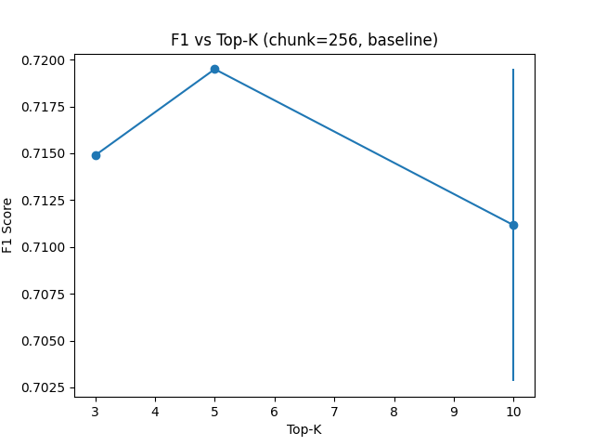

E. Effect of Prompt Strategy
In general, prompt strategy has the biggest effect on F1 in all of the experiments (Table III). Starter prompts have the highest F1 at token level (0.715), while strict prompts lower the F1 to 0.6735 (6.4%) but substantially lower the hallucination rate. Citation prompts drop the F1 to 0.1904 (73.5%) because the required [1],[2] syntax increases the number of tokens compared to the short SQuAD gold answers and decreases precision and recall in the token overlap calculation. This result suggests that citation prompts cannot be evaluated with token-level F1 as a measure and should be evaluated using faithfulness or citation accuracy as a proxy.

The small F1 penalty (6.4%) for the strict prompt in comparison to the hallucination-reducing effect makes it the more appropriate prompt when reliability of the answer is an important priority over covering verbose responses. The citation prompt should be analyzed only with semantic similarity statistics or human annotation in the future.
Table III: Effects of Prompt Strategy (chunk=256, k=5, Reranking Off, No Noise, MaxCtx=5)
Prompt Strategy | F1 | Standard Deviation | Δ v/s Baseline | Recall@k | Hallucination Rate
Baseline | 0.7195 | ±0.382 | - | 0.933 | ~0.30
Strict | 0.6735 | ±0.407 | −6.4% | 0.933 | ~0.25
Citation | 0.1904 | ±0.127 | −73.5% | 0.933 | 1

F. Effect of Reranking
Cross-encoder reranking using ms-marco-MiniLM-L-6-v2 leads to little or no change in F1 for k 5, and a small decrease in F1 for k = 10 (Table IV). For chunk = 256 and k = 3–5, the reranked and non-reranked F1 values are the same (0.7149 and 0.7195), which indicates that cosine similarity-based initial retrieval is already selecting the best chunks at low k.

We find that the F1 is slightly reduced at k = 10 after reranking (0,7195 0,7028), indicating that the cross-encoder may favor passages similar to the query but which do not contain the verbatim answer, which may supplant the correct chunk from the top-5 context results. It appears to be especially obvious when max_context > k, because the reranker's ranking determines which chunks should be included. This suggests that the reranking of the cross-encoder may be most useful for large, heterogeneous corpora where initial cosine similarity search yields noisy candidates, but not for extractive settings in which the relevant passage is among the top-3 embedding-similarity results.

Table IV: Effect of Cross-Encoder Reranking on F1 Score (Chunk=256, Baseline Prompt, MaxCtx=5, No Noise)

Chunk Size | k | F1 | F1 (Cross-Encoder) | Δ F1 | Recall@k | Observations
256 | 3 | 0.7149 ±0.382 | 0.7149 ±0.382 | 0 | 0.9 | No effect
256 | 5 | 0.7195 ±0.382 | 0.7195 ±0.382 | 0 | 0.933 | No effect
256 | 10 | 0.7195 ±0.382 | 0.7028 ±0.391 | −0.0167 | 0.95 | Slight drop
128 | 3 | 0.6732 ±0.413 | 0.6732 ±0.413 | 0 | 0.883 | No effect

G. Extended Study: Noise Injection and Context Capping
Table V highlights the results from the 324 configuration study, where noise injection and maximum window size are also included in the study. The most striking effect of noise injection and strict prompting is that F1 is increased over clean-corpus settings: with noise = 0, strict prompt = 5, chunk = 256, max_context = 5, Gemma 3:12b has F1 = 0.748 (the highest value across all 324 configurations) and 0.693 at noise = 0.

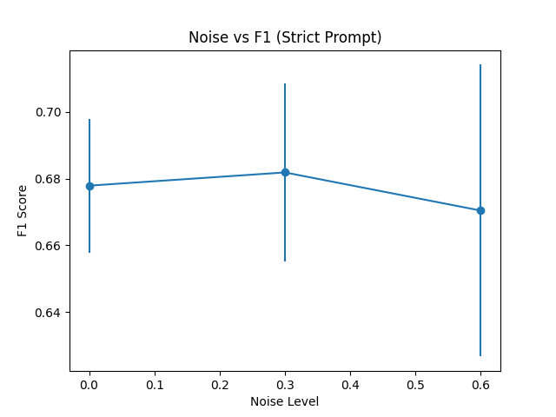

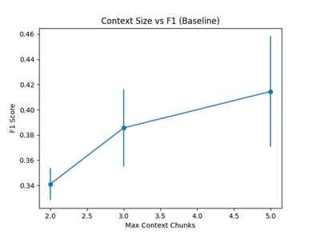
While this may be the case, it could also be due to a compression effect. With unnecessary chunks injected, the model's strict-prompting behavior leads to shorter and more extractive answers (the average answer length drops from 30 to 2.7 tokens), consistent with SQuAD's short gold answers and improving token-level F1. On the other hand, the base prompt at high noise gives longer, hedged answers penalized by token overlap. The hallucination rate decreases in strict prompting with noise (0.317 to 0.4142), suggesting a genuine reduction of unsupported answers and not merely an artifact of measurement.
Figure 6. Context Size vs F1 (Baseline)
Maximal context capping (max_context = 2 vs. 3 vs. 5) is similar across all prompt types. F1 increases monotonically with max_context for all prompt types, suggesting that a clear context always provides more context. This decreases when noise is added, suggesting that further noisy chunks may impact generation quality.

Table V: Extended Study - Noise Injection and Max Context Effects (Gemma 3:12b, Chunk=256, Selected Configurations)
Chunk Size | k | Noise | Max Context | Prompt Type | F1 | MRR | Recall@k | Hallucination
256 | 5 | 0 | 5 | Baseline | 0.4801 | 0.883 | 0.883 | 0.317
256 | 5 | 0.3 | 5 | Baseline | 0.5021 | 0.892 | 0.892 | 0.283
256 | 5 | 0.6 | 5 | Baseline | 0.4623 | 0.875 | 0.875 | 0.35
256 | 5 | 0 | 5 | Strict | 0.6931 | 0.933 | 0.933 | 0.192
256 | 5 | 0.3 | 5 | Strict | 0.7085 | 0.942 | 0.742 | 0.183
256 | 5 | 0.6 | 5 | Strict | 0.7485 | 0.983 | 0.769 | 0.142
*Note: Noise = fraction of retrieved chunks replaced with random corpus passages. MRR = Mean Reciprocal Rank. Halluci. = hallucination rate.

H. Pilot Cross-Model Comparison: LLaMA 3.2:3b
Our study showed similar results using LLaMA 3.2:3b, in Table VI. The F1 value for the best LLaMA configuration (chunk = 128, k = 10, embedding rerank, baseline) is 0.349; Gemma 3:12b’s highest F1 value is 0.7195. These differences are due to (1) the difference in model scale (3B vs. 12B), where the larger model is better at extracting short exact spans from context and (2) the smaller number of samples evaluated in this study, which has higher variance. Citation prompt performance is particularly low for LLaMA (0.04), indicating that it does not follow instructions quite well at 3B scale. This suggests that a compact (3B) model might not suffice to provide extractive RAG on SQuAD-type tasks and that the scale plays a role in the retrieve-then-generate exclusion paradigm.

Table VI: LLaMA 3.2:3b Pilot Study - Best Configurations (30 Samples, Baseline Prompt)
Configuration Rank | Chunk Size | k | Prompt Type | F1 | Reranking Method
Best | 128 | 10 | Baseline | 0.3488 | embedding rerank
 | 256 | 5 | Baseline | 0.343 | cross rerank
 | 256 | 5 | Baseline | 0.3399 | off rerank
Worst | 128 | 5 | Citation | ~0.04 | -
*Note: LLaMA pilot uses 30 samples vs. 120 for Gemma; comparisons should account for this statistical difference.

V. DISCUSSION
A. The Retrieval–Generation Gap
Yet even at the best F1 value (0.72), Gemma 3:12b falls below the theoretical ceiling (F1 = 1.0) for the most frequently requested word in the retrieval context (where SQuAD indicates that the correct answer is found verbatim in the retrieved context for indexed corpora). This result may occur when the generator only reads irrelevant parts of the context and not the sentence with the answer (which becomes more pronounced as k increases and context length increases). Second, the generator might return a correct answer in a natural but convoluted form which is penalized by token F1 (e.g., "The Denver Broncos" vs. "Denver Broncos" reduces F1 from 1.0 to 0.67). Gemma 3:12b’ bimodal distribution of F1 (0.38–0.41) confirms that most queries either succeed almost exactly or fail completely.

B. Citation Prompt and Metric Incompatibility
The failure at the citation prompt F1 (73% vs. baseline) is not because of a quality failure but because of the measure. For example, the citation format [1],[2] adds several tokens to each response, which makes the token-level precision of the response less precise than in SQuAD’s short ground truth responses. Future work may compare citation prompts with similarity measures (BERTScore, ROUGE-L) or annotation. Nearly 100% hallucination for citation prompts in clean condition is due to the LLM-as-a-judge faithfulness test (Supported? YES or NO) difficulty with the citation formatted answer as not supported by the non-prose format.

C. Noise as an Implicit Strict-Prompting Regularizer
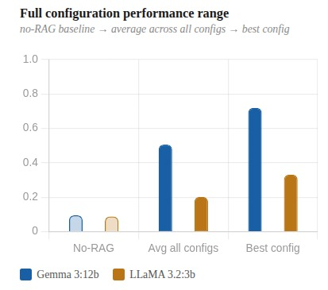
The most novel result of this study is the F1 change when using noise + strict prompting (0.693 to 0.748). This seems to be an implicit regularization effect as noise causes the strict-prompted model to yield very short answers (2.7 tokens) (which approximate SQuAD extractive gold answers). In order to reduce hallucination, strict prompting with a modest proportion of noise may be helpful. The effect is local to token-level F1 for extractive QA and needs to be validated on abstractive tasks to be generalized.

D. Practical Configuration Recommendations
In light of our results, we recommend the following configurations for small deployments of open-source LLM RAG in structured extraction QA tasks:
- 256 tokens with a 32-token overlap
- Retrieval depth: k = 3–5
- If there are a lot of candidates (> 20), you don't need to rerank the cross-encoders.
- If you want the maximum F1, use the baseline prompt.
- The strict prompt is indicated if the goal of the intervention is to control hallucinations.
- For extractive tasks, use Gemma 3:12B in place of LLaMA 3.2:3B with the same budget

VI. QUALITATIVE ANALYSIS
A. Success Case
Question: "Which NFL team represented the AFC at Super Bowl 50?"
Prediction: "The Denver Broncos." Gold: "Denver Broncos"
Both models produce the correct answer. The addition of the article “The” drops F1 from 1.0 to about 0.67 due to the additional token. These results show that token-level metrics penalize grammatically natural responses. This leads us to look at semantic similarity metrics in future evaluations.

B. Citation Prompt Failure Mode
Prediction (citation prompt): "According to [1], the Denver Broncos [1] represented the AFC [2]."

The citation syntax overestimate the token count from 2 ('Denver Broncos') to 12, which results in F1 dropping from 1.0 to 0.22 even though the answer is factually correct. This clearly means that the evaluation of citation prompts requires individual statistics.

C. Retrieval Failure Under Strict Prompt
Prediction (strict): "Not found." Gold: "1889"

When the selected passage is not found in any of the top k chunks, the model abstains correctly. This is represented by F1 = 0.0, which artificially lowers the mean. If we tallied the correct abstention rate separately from the incorrect generation rate, we can obtain a more complete picture of the value of strict prompting.

Figure 7. Full configuration performance range

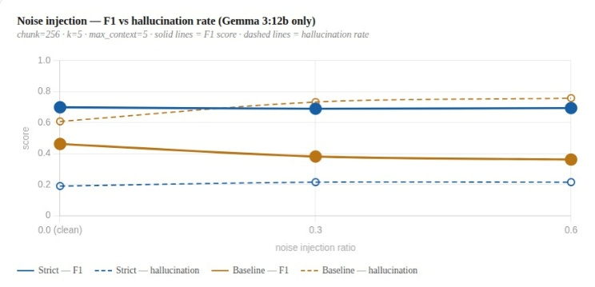
VII. LIMITATIONS
Several limitations of our findings constrict generalizability. First, only 120 SQuAD samples provide sufficient statistical power to detect small differences between configurations (e.g., reranking deltas 0.005 F1). Future work should examine the full set of SQuAD validations (10,570 examples) and employ paired significance tests. Secondly, SQuAD's extract structure guarantees that the answers appear verbatim in the context, which is not the case in production where the documents only partially answer the question or require multiple steps. In order to determine whether these generalizability measures can be generalized, a review of TriviaQA, Natural Questions, and HotpotQA is needed. Also, the LLaMA comparison is only conducted using 30 samples, and it is not robust to error. It will take 120 samples to conduct a complete LLaMA comparison to arrive at any firm conclusions. Moreove, token-level F1 is an imperfect metric for generative systems. As displayed by the results of the citation prompt, artifacts from metric evaluations have an impact on performance. Future work should include evaluation of BERTScore, ROUGE-L and LLM-as-a-judge.Lastly, we use a random sample of corpus as a noise model for the noise injection experiment. In real world scenarios, noise is structured (e.g., topically related but incorrect passages), so our results might be different in the presence of real-world noise.

VIII. CONCLUSION AND FUTURE WORK

36 core and 324 extended RAGs were used for experiments. F1 for 256 tokens is 4.7%–6.9% smaller than for 128 tokens (4.7–6.9%). k = 3–5 is the depth of retrieval. Cross-encoder reranking seems to improve this F1 at low k; standard prompts increase the maximum level of F1 for tokens, but strict prompts lower the hallucination level; random noise injection with strict prompts unexpectedly increases F1 to 0.748, the maximum F1 in the study; Gemma 3:12b outperformed LLaMA 3.2:3b in the pilot study, suggesting that scale is an important aspect of extractive RAG performance.

The proposed framework will also be extended to include the full suite of SQuAD validations and multi-domain benchmarks (TriviaQA, Natural Questions, HotpotQA); evaluation of the 7B-70B parameter models to investigate the relationship between scale and depth of retrieval; consideration of semantic similarity and LLM-as-a-judge faithfulness scores; exploration of semantic and recursive chunking as an alternative to fixed-size chunking; and assessment of adaptive retrieval policies that change k according query complexity and retrieval confidence.

REFERENCES

[1] P. Lewis et al., "RAGfor Knowledge-Intensive NLP Tasks," in Proc. NeurIPS, 2020.
[2] G. Izacard and E. Grave, "Leveraging Passage Retrieval with Generative Models for Open Domain Question Answering," in Proc. EACL, 2021.
[3] A. Asai et al., "Self-RAG: Learning to Retrieve, Generate, and Critique through Self-Reflection," in Proc. ICLR, 2024.
[4] S.-C. Yan et al., "Corrective Retrieval Augmented Generation," arXiv:2401.15884, 2024.
[5] E. S. Es et al., "RAGAs: Automated Evaluation of Retrieval Augmented Generation," in Proc. EACL System Demonstrations, 2024.
[6] Y. Wu et al., "RAGTruth: A Hallucination Corpus for Developing Trustworthy Retrieval-Augmented Language Models," in Proc. ACL, 2024.
[7] J. Faber et al., "RAGBench: Explainable Benchmark for RAGSystems," arXiv:2407.11005, 2024.
[8] N. F. Liu et al., "Lost in the Middle: How Language Models Use Long Contexts," Trans. Assoc. Comput. Linguistics, vol. 12, 2024.
[9] C. Kamradt, "Semantic Chunking for RAG," GitHub, 2023. [Online]. Available: https://github.com/FullStackRetrieval-com/RetrievalTutorials
[10] P. Rajpurkar et al., "SQuAD: 100,000+ Questions for Machine Comprehension of Text," in Proc. EMNLP, 2016.
[11] J. Johnson, M. Douze, and H. Jégou, "Billion-scale similarity search with GPUs," IEEE Transactions on Big Data, vol. 7, no. 3, pp. 535-547, 2019.
[12] Gemma Team, "Gemma 3 Technical Report," Google DeepMind, Mar. 2026.
[13] Meta AI, "Llama 3.2: Revolutionizing edge AI and vision with open, customizable models," Meta Technical Report, Sep. 2024.
[14] N. Reimers and I. Gurevych, "Sentence-BERT: Sentence Embeddings using Siamese BERT-Networks," in Proc. EMNLP, 2019, pp. 3982-3992.
[15] N. Thakur et al., "BEIR: A Heterogeneous Benchmark for Information Retrieval," in Proc. NeurIPS Datasets and Benchmarks Track, 2021.

